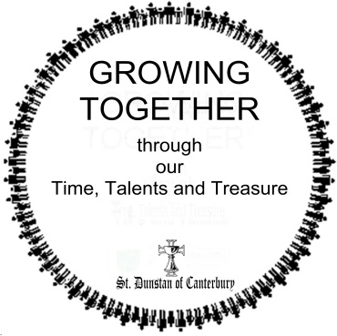
St. Dunstan of Canterbury
Stewardship 2017

October 2016

«AddressBlock»

Drawing Strength

«GreetingLine»

I know just how much I rely on my faith to guide me through the good times and the bad. Each day is a new beginning. I know that the only way to live my life is to try to do what is right, to take the long view, to give of my best in all that the day brings, and to put my trust in God … I draw strength from the message of hope in the Christian gospel.
Queen Elizabeth II, Christmas 2002

There is no doubt in my mind that we live within challenging times. Daily we receive news of unrest in our world through acts of terrorism, which sometime is very close to home. Economists have differing opinions as to the “health” of our national economy and that of the world. Our friends, south of the border, currently face racial tension in their cities and the same tension is beginning to be evident in Canada. I could go on and on, but that would only serve to be distressing.

Queen Elizabeth’s message though speaks of the “long view”; a sense of not being mired in the immediate, but looking forward to a way ahead. It is a powerful Stewardship theme, as true, good stewardship is always focused on the future, rooted in the present.

Once again we invite you to think ahead. But first, think of the strength you gain from being part of our vibrant parish. Reflect on the Christian gospel and the way our Sunday worship brings it to life and alive within your living. Recognize the renewed strength attending such a service imparts so you may enter into the challenges of the week ahead. It is truly a blessing. And then reflect on how impoverished life would be without such an opportunity.

Having done that, consider the generations yet to come and the challenges they will face. If we cannot give of ourselves to ensure this parish will be there for them, then shame on us! Stewardship is taking that longer view, to do what is right and to give of our best and to put our trust in God!

Enclosed in this package is a report about our parish’s well-being. We want you to know of the difference you are making in the lives of the people this parish serves. It is also about yourself, and your role within this parish. Gifting the parish with your time, talent and/or treasure are ways in which the grace and blessing God has bestowed on you is shared with the wider community.

Please fill out the intention card and return it to us, for it minimally allows us to keep our database up to date. If you feel moved by God to offer more of yourself through a gift, then we thank you.

In Christ,
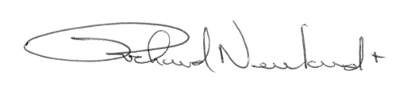
Richard Newland

