St. Dunstan of Canterbury Church
(Anglican Church of Canada)
www.stdunstan.ca

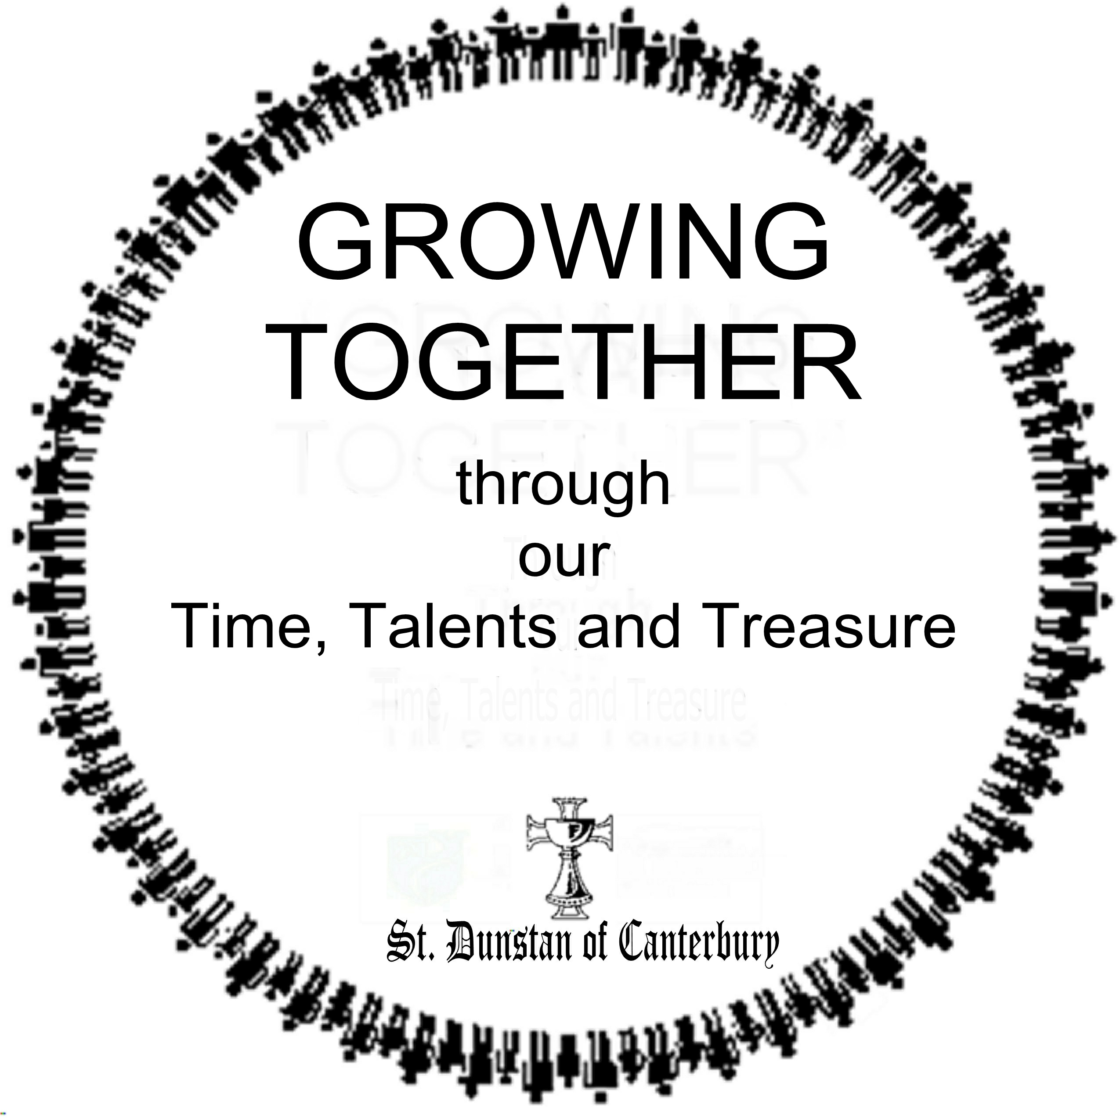

Narrative Financial Statement
Joyful Giving Programme & Relay
2016

We are Companions on the Journey

Companions

… in Worship
“Do not let Sunday be taken from you. If your soul has no Sunday, it becomes an orphan.”
(Albert Schweitzer)
The Ministry of Word and Sacrament is central to our congregation’s witness in our parish. We are blessed with a beautiful, modern and well-maintained building as our Church home and a rich heritage in our parish life. Music is an important component of our worship. We have developed a tradition of worship that is lively and inclusive and preaching that is relevant to our journey.

… in Christian Education
“The task of the modern educator is not to cut down jungles, but to irrigate deserts.”
(C.S. Lewis)
At St. Dunstan’s we believe growth in our knowledge of God and our faith is an essential aspect of life. Opportunities for education, fellowship, sharing and service provide the environment for the development of each person’s individual faith. Thus, we become better equipped to share our journey with others.

… in Evangelism
“We are told to let our light shine, and if it does, we won't need to tell anybody it does. Lighthouses don't fire cannons to call attention to their shining - they just shine.”
(Dwight L. Moody)
At St. Dunstan’s we are passionate about the faith we share. We want our church and its members to be a visible and relevant example of God’s reconciling love and justice in the world. What goes on outside the walls of this church is important. We also want to provide opportunities for those who are here to grow in an understanding of what it means to be a Christian witness on the Journey.

… in Outreach
“It is the duty of every Christian to be Christ to his neighbor.”
(Martin Luther)
Following the example of Christ, we are a Church committed to serve and care for those who may not have any connection to our church at all. The people of St. Dunstan’s live out our baptismal covenant to “seek and serve Christ in all persons” in a variety of ways. We engage in outreach projects that are local, diocesan and global in focus; providing food, clothing, toys, money and many volunteers. St. Dunstan’s is committed to supporting FaithWorks, part of the Diocese of Toronto’s outreach ministries.

… in Fellowship
“The Church is the new creation, it is life and joy, it is the sacramental fellowship in which we share the ultimate purpose of God, made real for us now in our hearing the Word and sharing the Sacrament.”
(Rowan Williams)
The earliest disciples were a group of people, not rugged individuals doing it on their own: Jesus sent the disciples out in pairs, St. Paul travelled with companions and later, missionaries would travel in groups. To be in the company of another, sharing in the journey is a powerful experience. We strive to be a welcoming, inclusive community where all who come into our space may find a companion and friend.

… Pastoral Care
“Friendship is born at that moment when one person says to another: “What! You too? I thought I was the only one.”
(C.S. Lewis)
Pastoral care includes a variety of ministry activities. Often it entails being with people in the church office, their homes, hospitals, nursing homes, and jails – wherever people with special needs are to be found. It can be comprised of crisis management, counseling, encouraging, and offering practical assistance and comfort. More than anything else, it is bringing the person of Jesus Christ into the cares and concerns of people’s lives. Ongoing spiritual guidance and support are made available to all who are open to it in whatever circumstance.

You are investing in a Mutual Fund
Think of your parish church as a mutual fund and your commitment of time, talent and treasure as deposits made to invest in that fund. Like all mutual funds you hope it will grow and prosper increasing the value of your investment. As well, you’ve invested in the mutual fund with the expectation of sound management and regular reporting of the fund’s performance. The money you invest in a particular fund is being managed by a fund manager (steward) and you trust the manager to make wise choices.

This document is a performance report of your mutual fund known as St. Dunstan’s. There is a wealth of material within this booklet, which we hope you will find informative. It is being provided to you so you can see how your investment is performing.

Only a small percentage of the congregation attend the annual Vestry meeting where budgets are passed and reports received. Decisions concerning your investment in this parish are made in your absence. This document is a report of the good stewardship the Churchwardens and Parish Council are providing.

The tables contain a financial statement comparing the annual budget approved by Vestry in February, to the actual dollar amounts spent and received as at 30 June, 2016. In other words: our financial picture half way through the current year.

The graphs show how those dollar amounts are categorized according to the Diocesan Stewardship guidelines. Stewardship categories are different from the day to day budgetary ones. To arrive at appropriate figures for the Stewardship charts, each budget line item was assigned a stewardship category, often proportionately distributed in more than one.

Stewardship is far more than money, for it involves the investment of your time and talents as well. Accordingly, there is information about the amount of volunteer hours that are freely given to carry out the incredible diversity of ministry this parish undertakes. Ministry is what every Christian does, not what the clergy are paid to do.

Finally there is a section about self-evaluation. Like investing in a mutual fund, we like to increase our investment when we know the fund is doing well. We believe, and we have been told by the Diocese, that we are doing reasonably well; not at the top but better than average. It is our hope that after reviewing this document you may feel empowered to increase your investment of time, or talent and/or treasure, as you set your financial plan or budget for 2017.

A final note: In 2013 we were one of six parishes to “pilot” the yearlong Stewardship model, and of this pilot group, the only parish to do the stewardship campaign as a relay. We were wildly successful, with our return rate more than double of all the other pilot parishes. Our relay methodology is now the Diocesan standard for stewardship education; just another way in which we have been successful, and share that success with others.
Property

Our church building IS the first impression people have as they arrive for a service. We regularly receive comments about how well maintained the building is. Our property leaves a lasting impression in the minds of first time visitors. It also gives you security to know that our building will be here to meet your needs for many years to come. Our church building is a reflection of who we are and our sense of self-worth.

Like everyone else in Canada we too must deal with the rising prices of commodities and services. Every effort is made to ensure your financial contributions are spent prudently and we are receiving good value for our money.

Property |  | Budget at  June 2016 | Actual at  30 June, 2016
 | Insurance | 4,100 | 5,050
Maintenance |  | 7,400 | 5,594
Telephone / Web Site |  | 2,500 | 2,831
 | Hydro | 6,750 | 7,285
 | Gas | 3,000 | 3,254
 | Water & Sewage | 1,250 | 246
 | Security | 375 | 181
Grass Cutting |  | 1,250 | 1,372
Snow Removal |  | 3,300 | 4,365
 | Waste Management | 2,500 | 2,251
Total Property |  | 32,425 | 32,429

Operations

At St. Dunstan’s we have a commitment to life-long learning for people of all ages. Our Children’s Church program is a dynamic enterprise reaching out to a growing number of children and youth. Adult Bible Study groups flourish and we provide a variety of resources such as the Upper Room and Our Daily Bread.

It takes physical resources to make this happen: photocopies, printers, computers and wireless networks. A good steward maintain these devices and upgrade them when appropriate.

To ensure all is properly accounted for, an independent auditor reviews the financial records of the parish to guarantee your gifts of treasure are appropriately accounted for.

Operations |  | Budget at  June 2016 | Actual at  30 June, 2016
Adult Ed |  | 600 | 328
Church School |  | 250 | 233
Worship Supplies |  | 1,500 | 1,637
 | Music | 1,500 | 250
Postage |  | 1,200 | 318
Office Supplies |  | 2,850 | 3,315
Equipment Lease |  | 2,000 | 2,666
Furniture & Equipment |  | 600 | 0
Discretionary |  | 500 | -140
Bank Charges |  | 750 | 1,198
 | Audit | 5,400 | 5,509
Miscellaneous |  | 1,500 | 752
Total Operations |  | 22,550 | 16,067

Salaries

Compensation is meant to attract, retain and reward, as well as motivate. Fair remuneration is a requirement of being a good steward of our human resources. Our staff work exceptionally hard to provide us the services, liturgically, pastorally and professionally that we expect.

Staff Salaries |  | Budget at  June 2016 | Actual at  30 June, 2016
 | Clergy | 73,951 | 74,603
 | Organist | 7,128 | 8,464
Music Director |  | 10,637 | 12,464
Administrator |  | 8,946 | 8,840
 | Janitor | 6,911 | 6,911
 | Sexton | 6,211 | 5,882
 | Supply | 0 | 1,100
 | WSIB | 275 | 221
Total Salaries |  | 114,059 | 118,485

Assessment
Our parish is part of something much larger, namely the diocese of Toronto and the Anglican Church of Canada and we have a commitment to assist their work. Through these organizations our funds help the needy and support various ministries that we do not directly. The Diocese levies an “assessment” on every parish within its jurisdiction. The amount each parish is to pay is based on the average of the last three years of income, less the total cost of clergy (our clergy are a tax deduction!), along with some other adjusting factors. Just like in life – the more successful you are, the more the “government” claim to be theirs.

Capital Improvements
We desire to be a community’s church and thus our facilities are utilized by many groups. All this traffic takes its toll and requires our due diligence to ensure a clean, safe and up-to-date facility. “Curb appeal” is a powerful evangelism tool, as people want to belong to something successful. First impressions are lasting impressions.

The year, 2016 will mark the end of the Our Faith, Our Hope campaign and in particular our responsibility to repay the amount we borrowed to install the steel roof on our church building. We have been successful because you have honoured your pledge to this project.

Assessment | Budget at  June, 2016 |  | Actual at  30 June, 2016
Diocese |  | 27,349 | 27,349
Synod Expense
Total Assessment |  | 27,349 | 27,349
Capital Improvements
Roof Repayment |  | 2,500 | 7,325
Asset Fund |  | 6,178 | 2,639
Capital Improvements |  | 0 | 0
Total Improvements |  | 8,678 | 9,964

Where Our Time and Talent Goes

Stewardship is about relationships. Many of our parishioners give of their time and talent through various means. We have a long list of groups, organizations and events that are integral to our common life together. In 2015 we undertook an extensive survey of how many volunteer hours were given to support these ministries. The graph opposite reflects those numbers, now expressed in a percentage of the total amount of volunteer hours.

There are many other ways in which we engage ourselves in the life of this parish that wouldn’t be reflected in the graph. Below, is a quick snapshot of our parish at June 30, 2016. You will see it has been a busy place!

Average Weekly Attendance: | 238
Easter Day Attendance: | 475
Baptisms: | 7
Weddings: | 1
Number of Hall Rentals: | 19
Number of Social Events: | 8
Funerals (of parishioners): | 0

That’s a lot of ushering, coffee hour hosting, providing reception food, and general hosting, cleaning, and partying!

Where Our Time and Talent Goes

Income

St. Dunstan’s has only five sources of income:
- Freewill offerings through Sunday collections
- Rental income from the use of our facilities
- Special activities such as weddings, advertising and fundraising
- Endowment income from our Housing Reserve.
- Receipts from the Diocesan Our Faith – Our Hope campaign (ending in 2016).

We rely on your support to promote all the opportunities available at St. Dunstan for worship, fellowship, fun and rental options. We strive to maximize the potential of our parish and the benefit we are to the wider community. The majority of our financial support is derived from your commitment to this parish. Collectively you and your fellow parishioners currently donate 64% of the total income, supporting the myriad of activity for which this parish is well-known.

We continue to rely on that generosity. We encourage you to utilize the convenience of Pre-Authorized Giving, a green eco-friendly way to demonstrate your commitment to the future well-being of St. Dunstan’s.

 |  | Budget at | Actual at
 |  | June 2016 | 30 June, 2016
Income
 | Envelopes | 131,500 | 130,932
Open Offering |  | 3,000 | 3,014
Visitor Envelopes |  | 2,500 | 1,710
Coin Drop |  | 250 | 7
Special Envelopes |  | 7,300 | 7,424
Total Collections |  | 144,550 | 143,087
Rentals
 | Hall (single events) | 3,000 | 8,059
Hall (ongoing events) |  | 5,000 | 7,550
Worship Space |  | 500 | 200
Cantel Tower |  | 19,500 | 19,500
Total Rentals |  | 28,000 | 35,309
Special Activities
 | Weddings/Funerals | 500 | 925
Advertising |  | 300 | 75
Miscellaneous |  | 500 | 585
Fundraising |  | 6,500 | 9,292
Total Special Activity |  | 7,800 | 10,877
Other Income
 | Housing reserve | 3,500 | 3,725
Donations |  | 3,000 | 1,878
Our Faith – Our Hope |  | 8,000 | 9,964
General Revenue |  | 1,750 | 8,154
Total Other Income |  | 16,250 | 23,721
Total Receipts |  | 196,600 | 212,994

“You make a living by what you get. You make a life by what you give.”
(Winston Churchill)
Stewardship
Why Should I Give?
- To express my thanks to God for all God has given me
- To support the current and future needs of St. Dunstan

How Much Should I Give?
We all live in different circumstances; some are single parents, some of us are pensioners, some of us have large mortgages, and some of us are just starting out in life. We see our incomes rise and fall. If your circumstances change, then so does your gift amount. The scriptures ask us to give according to our means. Another standard we find in the scriptures is tithing, or proportional giving. What is attractive about proportional giving is fairness – we give a stated percentage to our church. The percentage remains the same, but the actual dollar amount varies with changing circumstances.

In an article in the Globe and Mail, January 12, 2008, Simon Bell a congregational development officer with the Diocese of Toronto says “churches that try to continue as if they still exist in a culture of 1950s Christendom aren’t likely to survive.” The article pointed out that nationwide; Roman Catholics have closed nearly 10% of their churches, and the Protestant denominations about 12% each. Mr. Bell points out those churches without a precise mission and the resources to achieve their mission are not likely to make it.

Simply put we rely on your generosity to finance the ministry of our parish and to build toward a bright and vibrant future. Studies have shown that when parishioners give proportionately then parishes are on the road to financial health and well-being. The Diocese of Toronto has targeted a proportionate gift of 2% of household income as a standard that would ensure long-term financial security. We are currently only at 1.1% of household income (from the Benchmark Study).

Our understanding of stewardship as a way of life is based in scripture. The first chapter of Genesis tells us that God created all things, and created us to be the stewards of all creation. Being good stewards involves protecting our environment, as well as being concerned about the welfare of our fellow human beings. As stewards, we recognise that everything we have is a gift from God. We are, therefore, responsible to tend our gifts, to nurture them and then share their abundance in generosity and justice with all.

“Stewardship is the way to spiritual health and maturity, but for stewardship to have a chance we must begin with a serious spiritual question: What do we owe to God for the free gift of life and its accompanying benefits? The answer, of course, is everything.” (John Westerhoff)

To be true stewards we must gladly share with others our time, our talent and our treasure without ceasing. The lesson of scripture is not to be viewed in isolation from our daily lives. Instead, the teaching provides a real and complete guideline for our relationship with Christ and how we are to live our lives as Christ’s followers. The Great Commandment makes clear what we must do: “Love the Lord your God with all your heart, with all your soul, with all your mind and with all your strength” (Mark 12:30). And the second is like unto this: “you shall love your neighbour as yourself” (v.31).
How do we interpret Christ’s teaching within the context of stewardship? As a lived example, Christ taught us about loving our enemies, being charitable to others, our relationship with our possessions, abundance and grace, worship, suffering and surrender. His teachings and life are our model: “It was for this that God called you, for Christ himself suffered for you and left you an example, so that you would follow in his steps” (1Peter 2:21). Embracing a life of Christian stewardship is how we offer thanks to God for what God is already doing for us.

Proportionate giving means that shares of our personal resources of time, talent and treasure are being devoted to the Lord’s work on a regular schedule. It is a commitment made in response to the love which God has shown for us through Jesus, as well as in the events of daily life. It is an offering of “ourselves, our souls and bodies.”

The goal – though not without its challenges – is actually quite clear: an hour’s pay from each of our givers. An hour’s pay is an attractive metaphor for any sacrificial giving initiative. For those who are retired we encourage them to consider giving the equivalent of an hour’s pay from their retirement income.
St. Dunstan’s is known for its Christian witness, its outreach, its passion for good liturgy and welcoming hospitality. People gather faithfully in this sacred space to worship God, to be strengthened in community, and to be empowered for work in the world. Our Christian stewardship in this parish requires each of us to examine prayerfully our commitment of time, talent and treasure to this important ministry.

Proportionate Giving Worksheet

From the Old Testament we learn that the people were to give of their “first fruits.” The same principle applies to us today: to give the first fruits of our labours to God through the Church. We should also give in proportion to what God has given us. Some people use the “modern-day” tithe, 5% of all income, as a guide for their giving (2.5% to church and 2.5% to charity). Others use an hour’s earnings as their contribution. Each person must determine what is appropriate.

This worksheet offers a means of determining one’s present percentage level of pledged financial support for the local church and establishing a commitment for the coming year. It is not to be returned to the church. It is intended for personal use with prayerful consideration in the privacy of your home.

- To find your current level of local church support, divide your pledge by your net income for the same period.

Example: Your figures:

A. Current Net Income $ 60,000 $___________
B. Current Pledge $ 600 $___________
C. Current Percentage Level ____1.0% ___________%
(Divide line B by line A)

- A financial commitment for the coming year might be based on one of the following options:

Modern Day Tithe

A. Expected Income $ 60,000 $___________
B. Tithe (2.5% church/2.5% charity) ____ 5% ______ __5%
C. New Commitment $__ 3,000 $___________
(Multiply line A by line B)

An Hour’s Wage

A. Weekly Income $ 1200 $___________
B. Hours in Work Week _____ 40 _______ 40
C. New Weekly Commitment $__ 30 $___________
(Divide line A by line B)

Just as the Father gives his very self to his children,
so must I give my very self to my brothers and sisters.

(Henri Nouwen, The Return of the Prodigal Son)

